**CASE STUDY: TARGET CORPORATION**

**Import the dataset and do usual exploratory analysis steps like checking the structure & characteristics of the dataset:**

**1. Data type of all columns in t he "customers" table.**

# • Query

SELECT column_name, data_type

FROM `robotic-shelter-

390304.Target_Corporation.INFORMATION_SCHEMA.COLUMNS`

WHERE table_name = 'customers';

# • Screenshot of Output

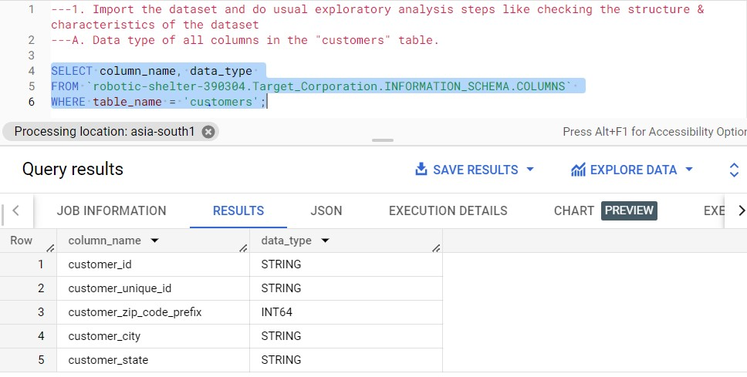

# • INSIGHTS

➢ By using this query, we can display the data type of each column present in the “customers” table.

# • Recommendations

➢ SQL data types can be broadly divided into the following categories.

1. Numeric data types such as: INT, TINYINT, BIGINT, FLOAT, REAL, etc.
2. Date and Time data types such as: DATE, TIME, DATETIME, etc.
3. Character and String data types such as: CHAR, VARCHAR, TEXT, etc.
4. Unicode character string data types such as: NCHAR, NVARCHAR, NTEXT, etc.
5. Binary data types such as: BINARY, VARBINARY, etc.
6. Miscellaneous data types - CLOB, BLOB, XML, CURSOR, TABLE, etc.

# • Assumptions

➢ By changing the table name in this query, we can display the data type of each column present in the other table also.

**2. Get the time range between which the orders were placed.**

## • Query

select distinct dataset_starting_date,dataset_ending_date from (SELECT first_value(order_purchase_timestamp) over(order by order_purchase_timestamp range between unbounded preceding and unbounded following) dataset_starting_date, last_value(order_purchase_timestamp) over(order by order_purchase_timestamp range between unbounded preceding and

unbounded following) dataset_ending_date

FROM `Target_Corporation.orders`) tlb

# • Screenshot of Output

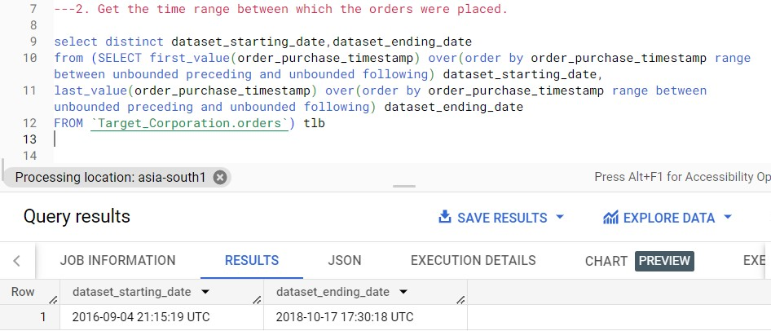

## • Insights

➢ In this query, we can get the date & time when the first and last orders in our dataset were placed.

## • Recommendation

➢ In this query, we used first_value and last_value window function to get the first and last value of the order_purchase_timestamp.

1. order_purchase_timestamp: - Timestamp of the purchase.
2. first_value(order_purchase_timestamp) over(order by order_purchase_timestamp range between unbounded preceding and unbounded following) dataset_starting_date: - this will provide first value in order_purchase_timestamp.
3. last_value(order_purchase_timestamp) over(order by order_purchase_timestamp range between unbounded preceding and unbounded following) dataset_ending_date: - this will provide last value in order_purchase_timestamp.

## • Assumption

* if the dataset update with new values, the query will show updated date & time of last order placed.
* By making minor changes in query like table name and timestamp of other dataset, we can get the date & time when the first and last orders in another dataset also.

**3. Count the Cities & States of customers who ordered during the given period.**

## • Query

select ct.city_count,st.state_count

from (select count(customer_city) as city_count, row_number() over () as rows_number from (Select customer_city from `Target_Corporation.customers` c left join `Target_Corporation.orders` o

on c.customer_id = o.customer_id where o.customer_id is not null group by customer_city order by customer_city)) ct

join (select count(customer_state) as state_count, row_number() over

() as rows_number from (Select customer_state from `Target_Corporation.customers` c left join `Target_Corporation.orders` o

on c.customer_id = o.customer_id where o.customer_id is not null group by customer_state order by customer_state)) st on ct.rows_number = st.rows_number;

# • Screenshot of Output

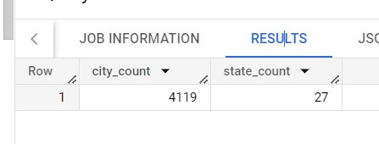

## • Insights

➢ We can count the number of unique cities and states present in our dataset.

## • Recommendation

* We join customer and order table by left join to find customers who ordered from Target Corporation. Then group by city then find the count of cities.
* In similar way, we join customer and order table by left join to find customers who ordered from Target Corporation. Then group by state then find the count of states.
* At last, we join the tables to display both the result as same table.

## • Assumption

➢ In this similar way we can find the count the Cities and States of the customers who ordered for other datasets.

**In-depth Exploration:**

**1. Is there a growing trend in the no. of orders placed over the past years?**

with yearmonth as

(SELECT order_id, customer_id,

FORMAT_TIMESTAMP("%Y-%m",order_purchase_timestamp) as year_month

FROM `Target_Corporation.orders`

order by order_purchase_timestamp)

select year_month, count(*) as order_placed_count from yearmonth group by year_month order by year_month

# • Screenshot of Output

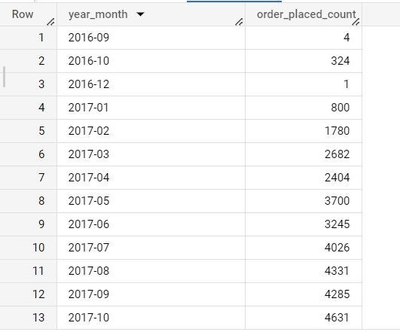

## • Insights

➢ We can find out if no. of orders placed has increased gradually in each month, over the past years.

## • Recommendation

* FORMAT_TIMESTAMP("%Y-%m", order_purchase_timestamp) as year_month: - by using this query be extract Year and month part from purchase timestamp. Which comes out 2016-09 to 2018-10.
* Make this as Common Table Expression(cte).
* Then using this cte make group by year_month, then count the order placed.

## • Assumption

* We can see in our data order gradually increases with year starts.
* We can see in our data order gradually decrease with year ends.

**2. Can we see some kind of monthly seasonality in terms of the no. of orders being placed?**

## • Query

with yearmonth as

(SELECT order_id, customer_id,

FORMAT_TIMESTAMP("%h",order_purchase_timestamp) as month FROM `Target_Corporation.orders` order by order_purchase_timestamp)

select month, count(*) as order_placed_count from yearmonth group by month

order by order_placed_count desc;

# • Screenshot of Output

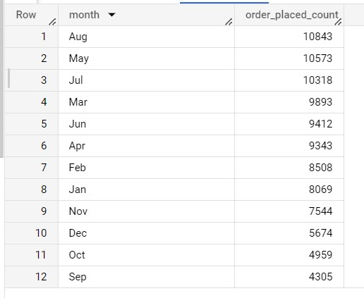

## • Insights

➢ In the query, we can find out if the no. of orders placed are at peak during certain months.

## • Recommendation

* FORMAT_TIMESTAMP("%h", order_purchase_timestamp) as month: - by using this query be extract month part from purchase timestamp.
* Make this as Common Table Expression(cte).
* Then using this cte make group by month, then count the order placed in that month over years.
* order by order_placed_count desc: - We order by order placed in descending order, to find the highest ordered month first then second and so on.

## • Assumption

* August, May and July have the highest ordered month.
* December, October and September have lowest ordered month.

**3. During what time of the day, do the Brazilian customers mostly place their orders? (Dawn, Morning, Afternoon or Night)**

## • Query

with hourday as

(SELECT customer_id, order_id, case when cast(hour as int) between 0 and 6 then 'Dawn'

when cast(hour as int) between 7 and 12 then 'Mornings'

when cast(hour as int) between 13 and 18

then 'Afternoon' else 'Night' end as Day_timing

FROM (SELECT customer_id, order_id,

FORMAT_TIMESTAMP("%H",order_purchase_timestamp) as hour

FROM `Target_Corporation.orders`) tbl)

select Day_timing, count(customer_id) as Count_of_customer from hourday group by Day_timing

order by Count_of_customer desc;

# • Screenshot of Output

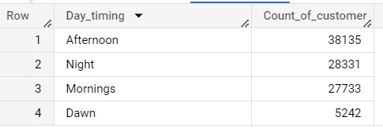

## • Insights

* In this query, we can categorize the hours of a day into the given time brackets/ intervals and find out during which intervals the Brazilian customers usually order the most.
* Time intervals: - **1.** 0-6 hrs: Dawn
  1. 7-12 hrs: Mornings
  2. 13-18 hrs: Afternoon
  3. 19-23 hrs: Night

## • Recommendation

* FORMAT_TIMESTAMP("%H",order_purchase_timestamp) as hour: - Using this query we extract hour from purchase timestamp and make that as subquery.
* Then using case when, we specify the Dawn, Mornings, Afternoon and Night, put it in column Day_timing.
* Make is whole as cte.
* Then using cte we group by Day_timing and count the order.

## • Assumption

* Most of the orders comes at Afternoon Day time.
* Least of the orders comes at Dawn Day time.

**Evolution of E-commerce orders in the Brazil region:**

**1. Get the month-on-month no. of orders placed in each state.**

## • Query

with city_month as

(SELECT o.customer_id, c.customer_state,

FORMAT_TIMESTAMP("%m",o.order_purchase_timestamp) as month

from `Target_Corporation.orders` o join `Target_Corporation.customers` c on o.customer_id = c.customer_id)

select customer_state, month, count(customer_id) as order_count from city_month

group by customer_state,month order by customer_state,month

# • Screenshot of Output

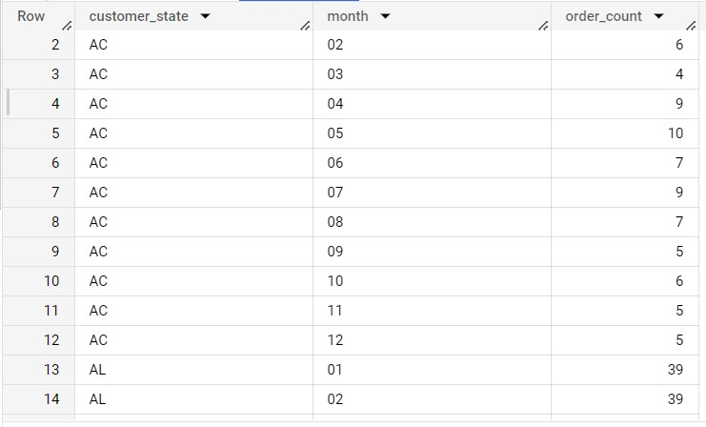

## • Insights

➢ In this query, we can get the no. of orders placed in each state, in each month by our customers.

## • Recommendation

* FORMAT_TIMESTAMP("%m", o.order_purchase_timestamp) as month: - Extract month from purchase timestamp.
* Join orders table and customer table.
* Make this as cte (Common table Expression).
* Use cte and group by customer_state and month part.
* Then count customer_id.
* Order by customer_state and month.

## • Assumption

* We can observe in the screenshot: - state name, month and order count.
* State: - SP have highest no. of orders, then RJ State, then MG States and so on

**2. How are the customers distributed across all the states?**

## • Query

SELECT customer_state, count(distinct customer_id) as count_of_customer

from `Target_Corporation.customers`

group by customer_state order by customer_state

# • Screenshot of Output

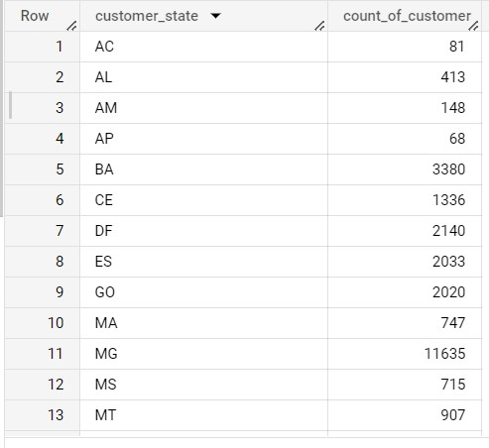

## • Insights

➢ In this query, we can get the no. of unique customers present in each state.

## • Recommendation

* Group by customer_state in table customers.
* Count distinct customers_id.

## • Assumption

* SP state have highest no. of customer, then RJ have second highest customer and the MG state.
* **Number of customers is directly proposal to Number order.**

**Impact on Economy: Analyze the money movement by ecommerce by looking at order prices, freight and others.**

**1. Get the % increase in the cost of orders from year 2017 to 2018 (include months between Jan to Aug only).**

## • Query

with monthyear as

(select o.order_id,FORMAT_TIMESTAMP("%m",o.order_purchase_timestamp) as month,

FORMAT_TIMESTAMP("%Y",o.order_purchase_timestamp) as year, payment_value

from `Target_Corporation.orders` o

join `Target_Corporation.payments` p

on o.order_id = p.order_id)

select tlb1.month, tlb1.year, tlb1.total_monthlycost2017, tlb2.year,

tlb2.total_monthlycost2018, round((((tlb2.total_monthlycost2018-

tlb1.total_monthlycost2017)/tlb1.total_monthlycost2017)*100),2) as percentage_increase,

from (select monthyear.month,monthyear.year, sum(payment_value) as total_monthlycost2017 from monthyear

where year = '2017' and cast(monthyear.month as int) between 01 and 08

group by monthyear.month, monthyear.year order by monthyear.month) tlb1

join (select monthyear.month,monthyear.year, sum(payment_value) as total_monthlycost2018 from monthyear

where year = '2018' and cast(monthyear.month as int) between 01 and 08

group by monthyear.month, monthyear.year order by monthyear.month) tlb2 on tlb1.month = tlb2.month order by tlb1.month;

# • Screenshot of Output

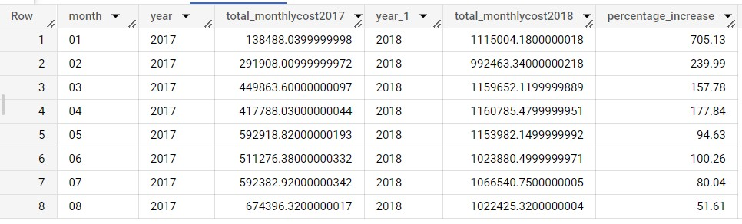

• Insights

➢ Percentage_ increase between months(January - August) over years.

## • Recommendation

* FORMAT_TIMESTAMP("%m",o.order_purchase_timestamp) as month: - Extract month from purchase timestamp.
* FORMAT_TIMESTAMP("%Y",o.order_purchase_timestamp) as year: - Extract year from purchase time stamp.
* Make this as cte.
* In one subquery find sum of months payment over year 2017.
* And in one subquery find sum of months payment over year 2018.
* Join both sub query.
* And find percentage increase over months using formula: - round((((tlb2.total_monthlycost2018tlb1.total_monthlycost2017)/tlb1.total_monthlycost2017)*100),2) as percentage_increase.
* Round function helps to round off 2 digits after point(.).
* Between Month January to August.

## • Assumption

➢ Highest percentage increase over month is in January: - 705.13% ➢ Lowest percentage increase over month is in August: - 51.61% ➢ We can find percentage increase over years.

with cte as(

select FORMAT_TIMESTAMP("%Y",o.order_purchase_timestamp) as year,

o.order_id,FORMAT_TIMESTAMP("%m",o.order_purchase_timestamp) as month, payment_value,

from `Target_Corporation.orders` o join `Target_Corporation.payments` p

on o.order_id = p.order_id)

,cte2 as(

select cte.year, sum(payment_value) total_payment_yearly from cte

where cast(cte.month as int) between 01 and 08 group by cte.year order by cte.year)

,cte3 as

(select *, lag(cte2.total_payment_yearly) over(order by cte2.year) as lag_total_payment from cte2)

select *,round((((cte3.total_payment_yearly-

cte3.lag_total_payment)/cte3.lag_total_payment)*100),2) as percentage_increase from cte3

order by cte3.year;

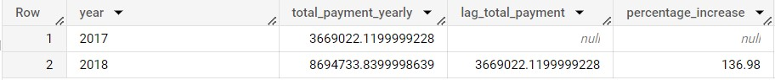

➢ Percentage Increase over Year 2017-2018 is 136.98%.

**2. Calculate the Total & Average value of order price for each state.**

## • Query

SELECT distinct customer_state,

sum(payment_value) over(partition by customer_state order by

customer_state) as total_orderprice,

round(avg(payment_value) over(partition by customer_state order by customer_state),2) as avg_orderprice from `Target_Corporation.customers` c join `Target_Corporation.orders` o on c.customer_id = o.customer_id join `Target_Corporation.payments` p

on o.order_id = p.order_id order by customer_state;

# • Screenshot of Output

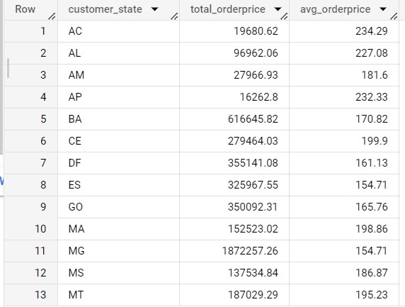

## • Insights

➢ In this query, we can fetch the total price and the average price of orders for each state.

## • Recommendation

* round(avg(payment_value) over(partition by customer_state order by customer_state),2) as avg_orderprice: - using this window function of average of payment_value of states
* We join three Tables customers, orders and payments.
* Customer table helps in finding state.
* Order table helps in order details.
* Payments table helps in finding payment_value.

## • Assumption

* PB State have highest average price of order: - 248.33
* Highest total_orderprice SP State: - 5998226.96
* SP State have lowest average price of order: - 137.5 ➢ Lowest total_orderprice AP State: - 16262.8
* We see SP State has high total sale but low Average

**3. Calculate the Total & Average value of order freight for each state.**

## • Query

SELECT distinct customer_state,

sum(freight_value) over(partition by customer_state order by customer_state) as total_freight_value,

round(avg(freight_value) over(partition by customer_state order by customer_state),2) as avg_freight_value from `Target_Corporation.customers` c

join `Target_Corporation.orders` o

on c.customer_id = o.customer_id join `Target_Corporation.order_items` oi on o.order_id = oi.order_id order by customer_state;

# • Screenshot of Output

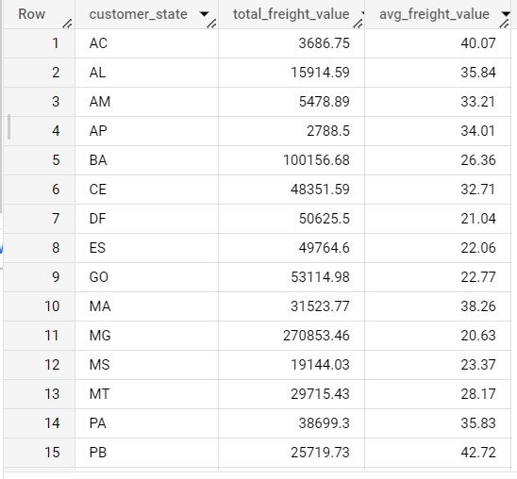

## • Insights

➢ In this Query, we can fetch the total freight value and the average freight value of orders for each state.

## • Recommendation

* round(avg(freight_value) over(partition by customer_state order by customer_state),2) as avg_freight_value
* We join three Tables customers, orders and order_item.
* Customer table helps in finding state.
* Order table helps in order details.
* Payments table helps in finding freight_value.

## • Assumption

* RR State have highest average Freight of order: - 42.98
* Highest Total Freight value: - SP State 718723.07
* SP State have lowest average Freight of order: - 15.15 ➢ Lowest Total Freight value: - RR State 2235.19

**Analysis based on sales, freight and delivery time.**

**1.** Find the no. of days taken to deliver each order from the order’s purchase date as delivery time.

Also, calculate the difference (in days) between the estimated & actual delivery date of an order.

Do this in a single query.

## • Query

SELECT order_id, customer_id,order_status, case

when order_delivered_customer_date is null then 'Cancelled/Unavailable'

else cast(date_diff(order_delivered_customer_date, order_purchase_timestamp, day) as string)

end as time_to_deliver, case

when order_delivered_customer_date is null then 'Cancelled/Unavailable' else

cast(date_diff(order_estimated_delivery_date, order_delivered_customer_date, day) as string) end as diff_estimated_delivery from `Target_Corporation.orders` order by order_id

# • Screenshot of Output

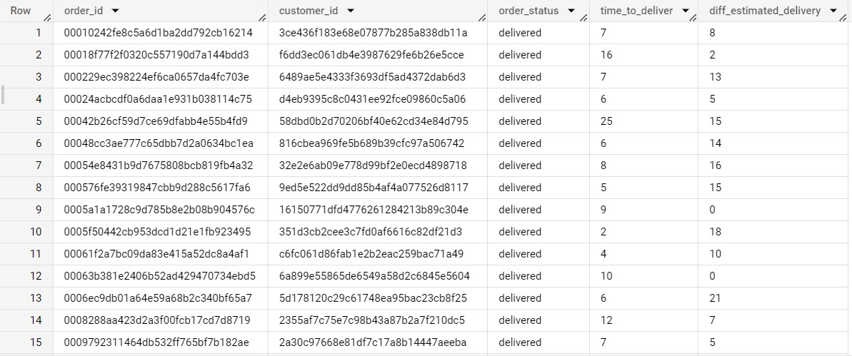

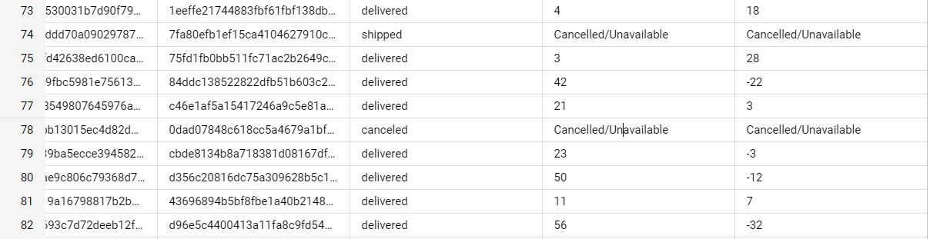

## • Insights

➢ In this Query, we can calculate the delivery time and the difference between the estimated & actual delivery date using the given formula:

* time_to_deliver = order_delivered_customer_date - order_purchase_timestamp
* diff_estimated_delivery = order_estimated_delivery_date - order_delivered_customer_date

## • Recommendation

* date_diff(order_delivered_customer_date, order_purchase_timestamp, day):- this function help in find the difference in dates.
* Case when helps in finding cancelled and Unavailable.

## • Assumption

* time_to_deliver: - Differences in order_delivered_customer_date and order_purchase_timestamp.
* diff_estimated_delivery: - Differences in order_estimated_delivery_date and order_delivered_customer_date
* In row 74 order is shipped but never reach the customer.
* In row 76,79,80 and 82 has negative values then it means order is deliver more days then estimated delivery time.

**2. Find out the top 5 states with the highest & lowest average freight value.**

## • Query

(select customer_state,avg_freight_value,'highest' as level from(select*,dense_rank() over(order by avg_freight_value desc) as ranking

from(SELECT distinct customer_state,

round(avg(freight_value) over(partition by customer_state order by customer_state),2) as avg_freight_value, from `Target_Corporation.customers` c join `Target_Corporation.orders` o

on c.customer_id = o.customer_id join `Target_Corporation.order_items` oi on o.order_id = oi.order_id order by avg_freight_value) a order by ranking) b where ranking <= 5)

UNION distinct

(select customer_state,avg_freight_value,'lowest' as level from(select*,dense_rank() over(order by avg_freight_value) as ranking

from(SELECT distinct customer_state,

round(avg(freight_value) over(partition by customer_state order by customer_state),2) as avg_freight_value, from `Target_Corporation.customers` c join `Target_Corporation.orders` o

on c.customer_id = o.customer_id join `Target_Corporation.order_items` oi on o.order_id = oi.order_id order by avg_freight_value) a order by ranking) b

where ranking <= 5) order by avg_freight_value desc;

# • Screenshot of Output

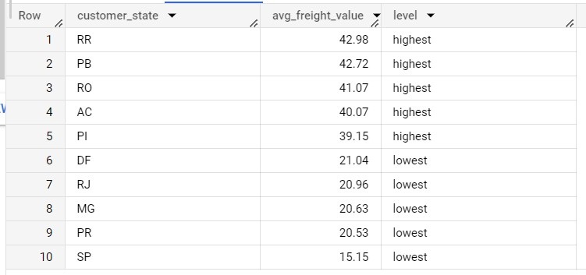

## • Insights

➢ In This Query, we can find the top 5 & the bottom 5 states arranged in increasing order of the average freight value.

## • Recommendation

* round(avg(freight_value) over(partition by customer_state order by customer_state),2) as avg_freight_value: - find the average of freight_value.
* Make this in subquery and the put dense_rank() on subquery to find top 5 highest avg freight value. dense_rank() over(order by avg_freight_value desc) as ranking.
* In Similar way we find top 5 lowest avg freight value. dense_rank() over(order by avg_freight_value) as ranking.
* And at last union both of them.

## • Assumption

* 1-5 top 5 highest avenge freight value states.
* RR State have highest avenged freight value state. ➢ 6-10 top 5 lowest avenge freight value states
* SP State have lowest avenged freight value state.

**3. Find out the top 5 states with the highest & lowest average delivery time.**

## • Query

with cte as

(select distinct customer_state, round(avg(c.time_to_deliver),2) as avg_time_to_deliver

from (SELECT customer_state, date_diff(order_delivered_customer_date, order_purchase_timestamp, day) as time_to_deliver from `Target_Corporation.customers` c join `Target_Corporation.orders` o

on c.customer_id = o.customer_id) c group by customer_state)

(select customer_state, avg_time_to_deliver,'highest' as level from(select customer_state, cte.avg_time_to_deliver,dense_rank() over(order by cte.avg_time_to_deliver desc) as ranking from cte) where ranking <= 5)

UNION ALL

(select customer_state, avg_time_to_deliver,'lowest' as level from(select customer_state, cte.avg_time_to_deliver,dense_rank() over(order by cte.avg_time_to_deliver) as ranking from cte) where ranking <= 5)

order by avg_time_to_deliver desc

# • Screenshot of Output

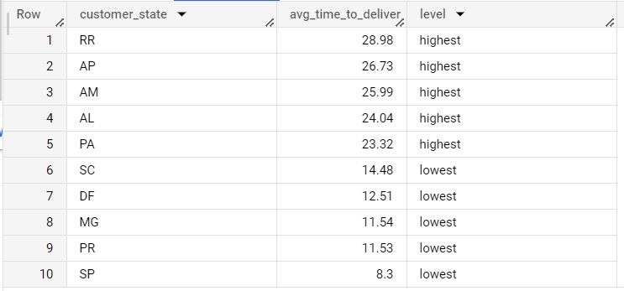

## • Insights

➢ In this Query, we can find the top 5 & the bottom 5 states arranged in increasing order of the average delivery time.

## • Recommendation

* date_diff(order_delivered_customer_date, order_purchase_timestamp, day) as time_to_deliver: - date difference to find delivery time.
* Avg() on delivery time of states.
* Make this in cte and the put dense_rank() on cte to find top 5 highest avg freight value. dense_rank() over(order by cte.avg_time_to_deliver desc) as ranking
* In Similar way we find top 5 lowest avg freight value. dense_rank() over(order by cte.avg_time_to_deliver) as ranking ➢ And at last union both of them.

## • Assumption

➢ 1-5 top 5 highest avenge time to deliver states. ➢ RR State have Highest delivery time average. ➢ 6-10 top 5 lowest avenge time to deliver states ➢ SP State have lowest average Delivery time.

**4. Find out the top 5 states where the order delivery is really fast as compared to the estimated date of delivery.**

## • Query

with cte5 as

(select customer_state, round(avg(diff_estimated_delivery),2) as

avg_diff_estimated_delivery

from (select customer_state, date_diff(order_estimated_delivery_date, order_delivered_customer_date, day) as diff_estimated_delivery

from `Target_Corporation.customers` c join `Target_Corporation.orders` o

on c.customer_id = o.customer_id where order_status = 'delivered') f group by customer_state)

select customer_state, avg_diff_estimated_delivery,

from(select customer_state, avg_diff_estimated_delivery,dense_rank() over(order by avg_diff_estimated_delivery) as ranking from cte5) where ranking <= 5

order by avg_diff_estimated_delivery;

# • Screenshot of Output

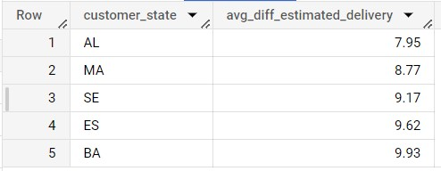

## • Insights

* In this Query, we find top 5 states where the order delivery is really fast as compared to the estimated date of delivery.
* We can use the difference between the averages of actual & estimated delivery date to figure out how fast the delivery was for each state.

## • Recommendation

* date_diff(order_estimated_delivery_date, order_delivered_customer_date, day) as diff_estimated_delivery: - Date Difference to find estimated date of delivery.
* Join two table customers and orders. ➢ Where clause to filter delivered ordered ➢ Make it as cte.
* Using cte us dense_rank() we find the top 5 states where the order delivery is really fast as compared to the estimated date of delivery.

## • Assumption

➢ AL State fastest order delivery

**Analysis based on the payments:**

**1. Find the month on month no. of orders placed using different payment types.**

## • Query

with cte5 as

(SELECT FORMAT_TIMESTAMP("%Y",o.order_purchase_timestamp) as year, FORMAT_TIMESTAMP("%m",o.order_purchase_timestamp) as month,

p.payment_type

from `Target_Corporation.orders` o

join `Target_Corporation.payments` p

on o.order_id = p.order_id order by year, month,p.payment_type)

select cte5.year,cte5.month,payment_type, count(payment_type) as payment_type_count from cte5

group by cte5.year, cte5.month, payment_type order by year, month,payment_type;

# • Screenshot of Output

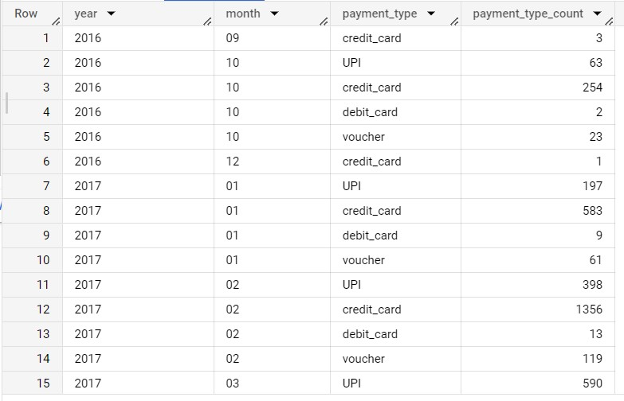

## • Insights

➢ In this Query, we can count the no. of orders placed using different payment methods in each month over the past years.

## • Recommendation

* FORMAT_TIMESTAMP("%Y",o.order_purchase_timestamp) as year, FORMAT_TIMESTAMP("%m",o.order_purchase_timestamp) as month: - Extract year and month from purchase timestamp.
* Join tables orders and payments.
* We take out payment_type from payments table.
* Make it as cte.
* Using cte we group by year, month and payment_type.
* Count payment_type.

## • Assumption

* Mostly people are using Credit Card to pay.
* UPI Second highest.
* Third is Vouches.

**2. Find the no. of orders placed on the basis of the payment installments that have been paid.**

## • Query

select payment_installments, count(order_id) as no_order_based_on_installment from `Target_Corporation.payments`

where payment_installments >= 1 and payment_value > 0

group by payment_installments order by payment_installments;

# • Screenshot of Output

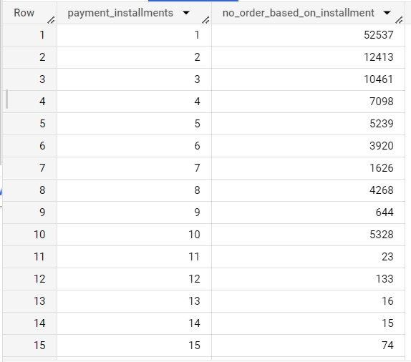

## • Insights

➢ In this Query, we can count the no. of orders placed based on the no. of payment installments where at least one installment has been successfully paid.

## • Recommendation

* Using Table payment.
* where clause for filter payment_installments >= 1 and payment_value > 0 ➢ Group by payment installment.
* Count order id.

## • Assumption

➢ Most of the people paid in 1-2 instalments

**Submitted BY: - Smit Singh**

**Batch: - dsml-june-23-beginner-mor-mon-batch**